 (HHA/CNA Application)
1150 NW 72nd Ave, Suite 450 Miami, FL 33126
(305) 330-1993
(305) 330-1993

In-services:
1. HIPAA
2. Infection Control
3. HIV/AIDS
4. OSHA
5. Domestic Violence
6. Medical Errors
7. Alzheimer’s

Documents:

8. CPR
9. Driver License
10. Car Insurance and Registration
11. Social Security Card
12. Professional License (CNA)
13. Proof of immigration status
14. FLDE (Background screening)
15. Physical Exam (Including PPD and/or chest X-ray)
16. Professional Liability Insurance (CNA)
17. HHA 40 Hours and 35 hours/75 hours

PERSONNEL FILE MANTENANCE/FOLLOW UP

EMPLOYEE NAME: __________________________ TITLE: ___________
DOB: _____________________
- Application and/or Resume ______
- References Obtained(2) ______
- Statement of Good Moral Character ________
- Confidentiality Statement _______
- Emergency Contact Form ______
- Employee Safety Checklist _______
- Orientation Checklist ______
- Conflict of Interest Disclosure _______
- Infection Control Form _______
- Noticed of Introductory Period _____
- Employee Job Description ______
- Competency Evaluation _____ On Site Sup. Visit ______
- Waived Testing Comp. Completed _______
- Test (HHA) _______

- Current Year W-4 ______
- Copy of Current License/ Certificate (If Applicable) _____
- License Verification _______
- Proof of Professional Liability Insurance (If Applicable) ______
- Copy of Current Driver License _________
- Copy of Current Social Security Card________
- Copy of CPR Card _____
- Copy of Alien Card (If Applicable) _____
- Copy of Initial 4 Hours of HIV/AIDS (Biannually) _______
- Background Check(In Envelope)( Copy of all the online sites) _______
- 12 Hours of In-services for HHA/CNA(Per Year) _____
SEPARATE BOOK:
__________ I-9

SEPARATE FILE (Medical File)

__________Physical Exam (Within 6 Month of Hire Only) ____________Hepatitis B (Signed/Dated)
__________TB Form (Signed/Dated)

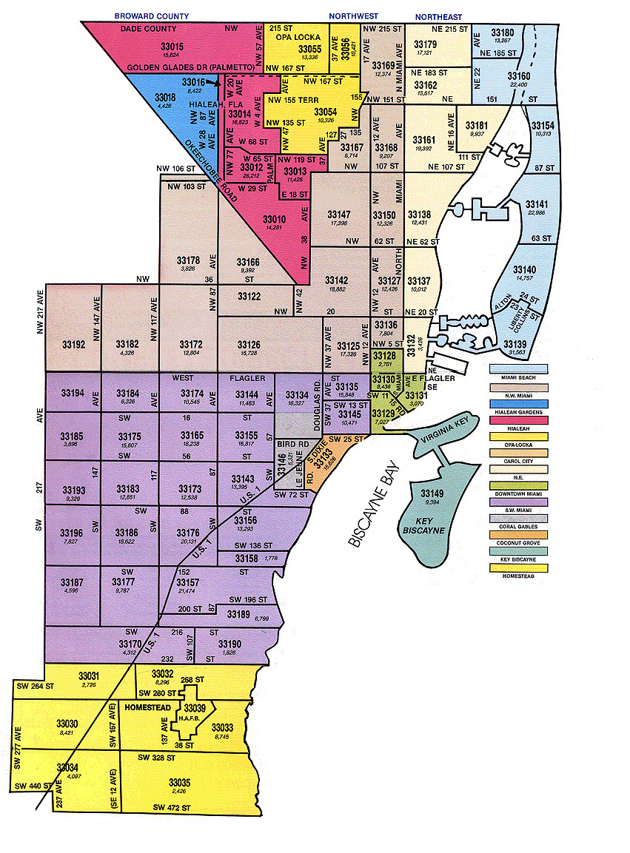

FF Home Health , LLC
Employment Application

We consider applicants for all positions without regard for race, color, religion, creed, gender, national origin, age, disability, marital or veteran status, or any other legally protected status.

APPLICANT INFORMATION
Last Name | First | M.I. | Date
Street Address |  |  | Apartment/Unit #
City | State |  | ZIP
Phone | E-mail Address
Date Available | Social Security No. |  |  | Desired Salary
Position Applied for
Are you a citizen of the United States? YES__ NO__ If no, are you authorized to work in the U.S.? YES__ NO__
Have you ever worked for this company? YES__ NO__ If so, when?
Have you ever been convicted of a felony? YES__ NO__ If yes, explain

EDUCATION
High School |  | Address
From To | Did you graduate? YES __ NO__ |  | Degree
College |  | Address
From To | Did you graduate? YES __ NO__ |  | Degree
College |  | Address
From To | Did you graduate? YES __ NO__ |  | Degree

REFERENCE
Please list three personal references
Full Name | Relationship
Company | Phone ( )
Address
Full Name | Relationship
Company | Phone ( )
Address
Full Name
Company | Relationship
Address | Phone ( )

PREVIOUS EMPLOYMENT
Company |  |  | Phone ( )
Address |  |  | Supervisor
Job Title |  | Starting Salary $ |  | Ending Salary $
Responsibilities
From To | Reason for Leaving
May we contact your previous supervisor for a reference? YES__ NO__
Company |  |  | Phone ( )
Address |  |  | Supervisor
Job Title |  | Starting Salary $ |  | Ending Salary $
Responsibilities
From To | Reason for Leaving
May we contact your previous supervisor for a reference? YES__ NO__
Company |  |  | Phone ( )
Address |  |  | Supervisor
Job Title |  | Starting Salary $ |  | Ending Salary $
Responsibilities
From To | Reason for Leaving
May we contact your previous supervisor for a reference? YES__ NO__

MILITARY SERVICE
Branch |  | From To
Rank at Discharge | Type of Discharge
If other than honorable, explain

DISCLAIMER AND SIGNATURE
I certify that my answers are true and complete to the best of my knowledge.
I authorize investigation of all statements contained in this application for employment as may be necessary in arriving at an employment decision.
I hereby understand I acknowledge that, unless otherwise defined by applicable law, any employment relationship with this organization is of and “at will” nature, which means that employee may resign at any time and the employer may discharge employee at any time with or without cause. Its further understood that this “at will” employment relationship may not be changed by an written document or by conduct unless such change is specifically acknowledge in writing by an authorized executive of this organization.
If this application leads to employment, I understand that false or misleading in my application or interview may result in my release
Signature___________________ Date_______________________
A Multi-Disease Management Company
5511 SW 8th St Suite 202
Miami, FL 33134
T: (305) 330-1993
F: (305) 330-1993
Medicare and Medicaid Certified
ACHC Accredited ISO 9001:2000 Standard.
Insured.

Reference information request

Reference Name: ____________________________________________________________
Agency Name: ___________________________________________________________
Telephone: (____)__________________
Fax number: (____)__________________
I have applied to the Agency for a position as a/an ___________________
I authorize you to respond to the questions below so they may act on my application. I release you from all liability in supplying this information regarding my employment with you.
Applicant’s Name: ______________________________
Applicant’s Signature: ___________________________

I worked for you from _________________to___________________ as a/an ___________________________________________________________________________
To be complete by former employer:
Would you rehire? Yes ________ No _________
Is the above information correct? Yes _________ No __________
If NO please explain: _________________________________________
Excellent Very Good Good Poor
Job Skill______________________________________________________________________
Job Knowledge________________________________________________________________
Initiative______________________________________________________________________
Attendance____________________________________________________________________
Ability to work with others_______________________________________________________
Judgment_____________________________________________________________________
Honesty______________________________________________________________________
Grooming and Appearance_______________________________________________________
Time Management______________________________________________________________
Comments:______________________________________________________________________________________________________________________

Signature: ___________________________
Title: ____________________________

Phone Reference Checklist

- Date Called: _____________________________________________________________
- Name of the company called:________________________________________________
- Phone number:___________________________________________________________
- Person Contacted: ________________________ Title:_________________
- Name of the applicant:_____________________________________________________
- Verify information supplied by applicant against data supplied by former employer. Note any differences according to:
Final position applicant held:________________________________________________
Date employed from: ___________________________ to: ___________________
Responsibilities: __________________________________________________________
Earning: ________________________________________________________________
(Verify $ amount from application)
- Ask former employer to briefly comment upon applicants about:
Attendance: ____________
Attitude:_______________
Job Knowledge:__________
Initiative:_______________
Quality of work:_________
- Would you rehire? Yes________ No__________

____________________________
Administrator/Designee Signature

Confidentiality Statement

I have been formally instructed regarding Agency Policy and procedures for maintaining the confidentiality of all information contained in client/personnel files and records as well as any other proprietary information regarding the agency that is obtained verbally.
I understand that, except as needed to conduct business, client and/or personnel information/proprietary information may not be discussed with anyone, either inside or outside the Agency.
I understand that medical records will not be removed from the Agency office unless the client has signed a “Release of Information Form”, and the removal of such information is approved by the Agency Administrator and/or designee.
I understand that any breach of confidentiality may be grounds for immediate termination of employment.

____________________________________ _______________
Employee’s signature Date

____________________________________ _______________
Witness’s signature Date

Emergency Contact Form

Employee name:_____________________________________ Date: ______________
Position: ________________________________________________________________

In case of an emergency you can contact the following people:
Name: _____________________________________ Relationship: __________________
Address:_________________________________________________________________
City:_________________ State: ____________ Zip code: _______________
Phone number: (____)_______________
Second emergency contact (friend or relative not living with you)
Name:___________________________________________ Relationship:____________
Address:_________________________________________________________________
City: ___________________ State:_______ Zip code: ______________
Phone number: (_____)______________

Employee Safety Checklist
Date: _______________________________________________________________________
Employee: ___________________________________________________________________

Employee will initial each box when instruction is completed and all questions/ concerns have been answered.
- General safety policy and program [ ]
- Safety rules-general [ ]
- Safety rules-specific to job [ ]
- Employee counseling (discipline for safety policy
Safety policy violation) [ ]
- Fire prevention, location of fire fighting
Equipment and location of exits. [ ]
- Disaster Planning/ Emergency Preparedness [ ]
- How, when and where to reports injuries. [ ]
- Housekeeping and cleaning up spills [ ]
- When and where to report unsafe conditions [ ]

On _________________________________, I reviewed the above checked items relating to the safety rules and safe work procedures for the Agency.

____________________________ _____________________________
Employee’s Signature Administrator/Designee Signature

Employee Orientation Checklist

Employee Name: ____________________ Position: __________________

Date of Hire: _____________________

Topics | Completed
Introduction to staff and tour of the agency
Scope of Services
Agency policies and procedures
Company Mission/Philosophy/Goals and Objectives
Organizational Structure/ Chart/Supervision
Conflict of Interest/ No-Discrimination Policy
Confidentiality of Information
Ethical Issues
Method of Assignment
Admission Criteria/Service and Care Limitations/Transfer/Discharge Criteria
Standards of Ethical Conduct/Issues/Considerations./Cultural Diversity/Sensitivity
Patient BILL of Rights/Responsibilities/Advances Directives/Living Will/DNR
Advance Directives
Universal precautions/Infection Control/OSHA including right to know laws/PPE
TB Exposure/HIV/HB/ Hazardous Waste Management Plan
Agency Corporate Compliance Plan/HIPAA Regulations
Performance Improvement Program
Abuse issues/Reporting
Accident/Incident/Unusual Occurrence Reporting
Grievance Reporting(Patient and Employee)
Emergency Management Program
Fire Safety/Emergency Preparedness/CEMP
Back Safety and Transfers
Requirements for employment, including training requirements, professional boundaries
Abuse issues/reporting
Employee Handbook
Job Descriptions/supervision, competency/evaluations
Quality Improvement Plan/
Handling patient Complaints/Grievance
Community Resources Available
Patient Instruction Materials
In-services(Non Direct Care Staff 8 hours and Clinical Staff 12 hours yearly)
Billing and payroll
Medicare Fraud
CPR Requirements
Acceptable Payer Sources/Conveying Charges to patient
DOCUMENTATION/PATIENT RECORDS
Admission/Intake Procedure
Admission Criteria
Admission/Transfer/Discharge Information/ OASIS Data Set
Time Frames For Documentation
Physician Verbal/Telephone Orders
Sixty Day & Discharge & Summaries
Medicare Regulations and conditions of Participation
Accreditation Standards
Reimbursement Guideline/Charges for Services

Employee Signature: ___________________________ Date: _______________

Human Resources Signature:____________________ Date: _______________

FF Home Health LLC
Employee Handbook Acknowledgement
This is to acknowledge that I have received a copy of the FF Home Health Employee Handbook and it provides an overview of the terms and conditions of my employment as well as my duties, responsibilities and obligations.
Policies and standards set forth in the Employee Handbook.
I acknowledge that I have been informed of the At-Will Policy of FF Home Health . The At- I understand and agree that it is my responsibility to read the Handbook and to abide by the rules, Will Policy states that.
I am employed by the Agency on an at-will basis, and my employment may be terminated at any time by me, or by the Agency, with or without cause. The At-Will nature of my employment may not be changed. No manager or employee in the organization has the ability or authority to alter this situation.
I also acknowledge that, except for the At-Will employment policy, the company reserves the right to revise, and modify the contents of the Handbook and that it is my responsibility to adhere to all current information.
I acknowledge that this Handbook is the sole property of FF Home Health LLC and is to be returned upon termination employment.

Employee Name: ______________________________________________________________
Employee’s signature: __________________________________________________________
Date: _______________________

Conflict of Interest Disclosure

(Please check the applicable paragraph and complete this statement as appropriate)
_____ I hereby affirm that I know of no issues that would present a conflict of interest arising from any situation related to my involvement/ association with__FF Home Health , LLC____.
______ I may have a conflict of interest arising from the following situation:
(Describe the potential conflict, including both the other entity in which you have an interest and the dealings it has with _____________________ and the appropriate date(s) the conflict arose.)
____________________________________________________________________________
____________________________________________________________________________
I understand that the Conflict of Interest Policy prohibits my involvement in transaction in which I have a conflict. Therefore, in any instance in which I may be required to participate in a situation impacted by such conflict, I will notify the Compliance Officer or the Administrator of the conflict of interest and will be abide by the resultant decision.

______________________________________ ____________ _____________
Print Employee name Title Date

______________________________________
Employee Signature

INFECTION CONTROL POLICY

I hereby acknowledge that I have read and understand the infection control policy, biohazardous waste disposal policy and at-risk behavior which promotes the spread of infectious diseases. I am familiar with the procedures appropriate to my position.

Employee Name: _________________________________
Employee Signature:______________________________
Date: _________________
Administrator/Designee Signature:_____________________

Notification of introductory period

Employee: ________________________________________________________________
Job Title: _________________________________________________________________
Social Security Number:_____________________________________________________
Date of hire: ______________________________________________________________
Probatory Date from: __________________ to:__________________________________

I, ______________________________________ in accepting employment with the Agency accept and understand the first 90 days of employment will be considered my introductory period. If for any reason my employment is terminated during this period, I understand and accept this account will not be charged with any unemployment benefits I may be eligible to receive under the State Unemployment Compensation Law.
I also understand and accept that at the end of the period, I will receive a written evaluation of my work performance. Should the Agency fail to provide this written evaluation, it shall be understood and accepted by all involved that the introductory period will have been completed satisfactorily.

________________________________________ _________________________
Employee’s signature Date
________________________________________ _________________________
Administrative Signature Date

Job Description
Home Health Aide

Reports to: Case Manager/ RN and Director of Nursing
Job Summary: Provides supportive and personal services for patients with consideration of dignity and privacy.
Duties and Responsibilities:
- Adheres to the written and verbal and verbal instructions of the skilled nurse/therapist in providing patient care.
- Provides assistance with personal care, hygiene and activities of daily living as directed.
- Measures and records vital signs and intake/ output as assigned.
- Observes for and reports any safety hazards found in the patient’s home.
- Observes for and reports any changes in the patient’s condition or other significant observations regarding the patient.
- Attends staff meetings and complete twelve(12) hours of in-services annually.
- Reports any patient concerns/complains of grievances to the Case Manager/Director of Nursing.
- Maintain patient confidentiality; complies with HIPAA requirements and Agency policies and procedures.
- Accepts assignments and provides patients care in compliance with the Aide scope of practice.
- Represents the Agency in a positive and professional manner.
- Complies with all Agency policies regarding ethical practices.
- Other duties as assigned by the RN for which the Aide is trained and has been competency evaluated.
Activities the Home Health Aide may not perform:
- Administration of medications.
- Irrigation of urinary catheters, colostomies or wounds.
- Naso-gastric or PEG tube feedings.
- Catheterizations.
- Changing sterile dressings.
- Any other service not included in the patient’s plan of care.
- Any services requiring the skills of a licensed nurse and/or therapist.

Qualification/Educational Requirements:
- Graduate of an accredited High School or equivalent preferred.
- Must provide evidence of formal training and/or certification as a Home Health aide as required by law.
- Must provide evidence of competency training and evaluation as well as evidence of attendance at the required number ( 12 hours) of in-services education programs.
- Minimum of one (1) year full-time experience in direct patient care in an institutional setting ( hospital or nursing facility), or one (1) year full-time experience within the last five (5) years in direct patient care in an agency setting. Home health experience preferred.
- Listed on the Nurse Aide Registry with no findingsagainst the Aide relating to patient abuse or neglect, or misappropriation of patient property.
- Able to follow written and verbal instructions.
- Good verbal and written communications skills.
- Emotional and mental maturity.
- Valid state driver’s license and reliable automobile with current automobile insurance.
- Current health certificate/physical examination and TB testing results.
- Current CPR Card.
Physical Demands:
- For physical demands of the position please see attached.
- Reasonable accommodations may be made to enable individuals with disabilities to perform the essential functions of this position without compromising patient care.
By my signature below I acknowledge that I have received, read and understand the job requirements of this position.
_______________________________________ _____________________
Employee’s name and Signature Date

______________________________________ _____________________
Agency Representative Signature/ Title Date

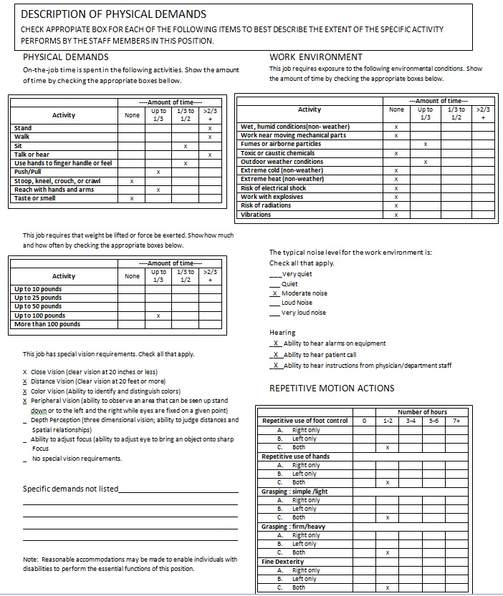
Skills Checklist
Home Health Aide

Name: ______________________________________________________________________

Instructions: Use the following answer key to indicate your previous experience.
- Needs Instruction 2. Needs Review 3. Competent to Perform Independently
SKILLS/TASK | Previous Experience | Instruction Given Date Initial
Hand washing
Handling/ Disposing of waste
PROCEDURES :
Ambulation of patient
Identifying patient needs
Bed positioning
Bedsore (care of Reinforce dressing)
Bowel Program
Denture Care
Documentation of Care
Diabetic symptom
Dying patient care
Death in in home (procedure for)
Foley catheter care
Catheter bags ( care of)
I&Os
Infant Care | n/a
Child Care | n/a
Oxygen Therapy
Range of motion exercises
Skin Care
Foot Care
Meal Preparation
Medication Assistance/reminder
Sitz Bath
Specimen Collection
Traction ( care of)
Transfers-bed/chair
Tube feedings
Vital Signs
Quadriplegic Care
Alzheimer Care
Meal preparation and planning
Light housekeeping and laundry

OTHER PROCEDURES:______________________________________________
______________________________________________________________________________
______________________________________________________________________________

____________________________________________ _____________________
Employee Signature Date

____________________________________________ ____________________
Supervisor Signature Date

PERFORMANCE EVALUATION
HOME HEALTH AIDE
Employee:_____________________________ Date Completed:________________________
Evaluation Period To: ___________________ From:_________________________________
Place the appropriate number that reflects work performance:
- Poor (re-education)
- Below average (at the time does not perform duties as expected)*.
- Average (perform as expected)
- Above Average (performs duty above expectations).
- Excellent (always performs duty above expectations).
- N.O. (not observed)
*If scope of 2 or less requires a comment.
---------------------------------------------------------------------------------------------------------------------
____ 1- Follows Personal Care Activities documented in a written assignment by a health ( RN or Therapist) professional. Activities include: assistance with personal care, hygiene, and activities of daily living
____ 2- Encourages client participation in activities to the extent to which the client is able.
____ 3- Assists with ambulation, eating dressing, shaving and physical transfer.
____ 4- Assists client to: a) bed, b) commode c) chair.
____ 5- Turns and positions bed bound clients.
____ 6- Measures and records temperatures, pulse and respiration on each visit.
____ 7- Maintains appropriates documentations of all services as per agency policies and procedures.
____ 8- Changes bed linen.
____ 9- Maintains a neat and clean environment.
____ 10- May grocery shop on the time a week for a list of ten items or less.
.____ 11- Informs supervisor of any changes in client’s condition or home situation

.____ 12- Performs any other task / duty that is specifically assigned by supervisor, and for which Aide has been specifically trained. Documentation of specific training must be included in employee’s personnel file, and are restricted to the following;
- ____ Assisting with the change of a colostomy bag, reinforcement of dressing.
- ____ Assisting with the use of devices for aid to daily living such as wheelchair or walker.
- ____ Assists client to follow exercise program
- ____ Assist with prescribed ice cap or collar
- ____ Prepare and measures simple meals following dietary instructions.
- ____ Measures and records intake/ output, as assigned.
____ 13- Supervises self-administrated medication in the home limited to the following:
- ____ Obtaining the medication container from the storage area, if applicable.
- ____ preparing necessary items such as juice, water, cups, or spoons to assist the the patient in in the self-administration of medication
- ____ Remaining the patient that it is time to take the medication as prescribed.
- ____ Observing the patient self-administering the medication.
____ 14- Conducts self in a professional manner at all times and in all situations.
____ 15- Provides agency with: a) required certificate, and b) necessary information to be able to verify experience
____ 16- Accepts only those assignments for which he/she is qualified
____ 17- Complies with all Agency policies and procedures.
____ 18- Communicates with Agency about any problems or concerns
____ 19- Complies with state regulatory acts .
Supervisor Comments: ___________________________________________________________
Employee Comments:____________________________________________________________

________________________________ _______________________________
Employee Signature/ Date Supervisor Signature/ Date

On-Site Evaluation

Employee:________________________________________ Date _____/_____/______

Mark One: ____ Probationary ______ Annual ______ other (specify)

- PREPARATION FOR VISIT | YES | NO
- Uniform dress/identification tag?
- Calls patient ahead before visit?
- Provides bag content : a) Supplies adequate?
b) Cleanliness?
- Organization of materials?
- Understands Assignment?
- ASSESSMENT OF SKILLS
- Temperature
- Pulse
- Respiration
- Bathing(specify):
- Hair Care
- Skin Care
- Nail Care
- Oral Hygiene
- Transfers/ Ambulation:
- Transfer belt
- Proper Body Mechanics
- Hoyer lift
- Transfers from bed to chair
- Toileting and elimination (specify):
- Positioning
- Range of motion
- TREATMENT TECHNIQUE
- Explanation to patient
- Treatment : Specify
- Proper draping of patient for privacy
- Use of universal precautions
- Gloves worn for the contact/ potential contact of blood/body fluids

Page 2
- Provider had appropriate personal protective equipment (PPE) to use when potential for exposure exists.
- Hand washing is performed as outlined in Infection Control and Safety Management Manual.
- Follows provider bad technique as outlined in the Infection Control and Safety Management Manual.
- Maintains a clean, safe, healthy environment
- EVALUATION OF DOCUMENTATION
- HHA Note
- Communicate with RN as needed
- Review of field chart
- Patient summary report
- HHA Care Plan
- Communication Log
- Reports changes in patient’s condition to Case Manager
ABILITY TO PERFORM NEW PROCEDURE/ TECHNIQUE
- Demonstrates new procedure/ technique appropriately
- Demonstrates use of equipment/ Type of equipment:
- Safely
- Appropriately
- EVALUATION OF SAFETY/ EMVIRONMENT
- Home
- Floors
- Electrical
- Phone
- Bathroom
- Stairs
- EVALUATION OF WASTE MANAGEMENT
- Safely
- Appropriately

SKILLS IDENTIFIED | IMPROVEMENT PLAN | PROJECTED COMPLECTION | ACTUAL COMPLECTION

_______________________ _____________________
Employee’ Signature Alejandro Ramos, DON

EVALUATION RESULTS

Employee’s name: _______________________________________ Date: _______________

Aide Test Sheet:

1-______ 33-______ 65-______ 97-______
2-______ 34-______ 66-______ 98-______
3-______ 35-______ 67-______ 99-______
4-______ 36-______ 68-______ 100-______
5-______ 37-______ 69-______ 101-______
6-______ 38-______ 70-______ 102-______
7-______ 39-______ 71-______ 103-______
8-______ 40-______ 72-______ 104-______
9-______ 41-______ 73-______
10-_____ 42-______ 74-______
11-_____ 43-______ 75-______
12-_____ 44-______ 76-______
13-_____ 45-______ 77-______
14-_____ 46-______ 78-______
15-_____ 47-______ 79-______
16-_____ 48-______ 80-______
17-_____ 49-______ 81-______
18-_____ 50-______ 82-______
19-_____ 51-______ 83-______
20-_____ 52-______ 84-______
21-_____ 53-______ 85-______
22-_____ 54-______ 86-______
23-_____ 55-______ 87-______
24-_____ 56-______ 88-______
25-_____ 57-______ 89-______
26-_____ 58-______ 90-______
27-_____ 59-______ 91-______
28-_____ 60-______ 92-______
29-_____ 61-______ 93-______
30-_____ 62-______ 94-______
31-_____ 63-______ 95-______
32-_____ 64-______ 96-______ _____________________________
Administrative Designee Signature

Employee authentic signature

I, _________________________________, certify that this is my true and authentic signature.

Resume of Educational Requirements

Employee name: ____________________________________ Job Title: _______________

In-service Title | Date | Hours | Total Hours

Employee Health Release for denial of T.B.
Signs and Symptoms for persons who have had BCG or positive T.B. Test in the past.
The early signs and symptoms of tuberculosis are as follows:
- Cough
- Night Sweats
- Fever
- Loss of weight
- Loss of Appetite
- Coughing Blood
I have read above information and do not know have these symptoms. If these symptoms develop I will contact my supervisor immediately for follow up.

_______________________________ ___________________________
Employee Signature Date

Hepatitis B Vaccination Consent

- I have read the information concerning Hepatitis B vaccination.
- I understand the benefits and risk of the Hepatitis B vaccination and have had the opportunity to ask questions.
- The vaccine will be administered in a serious of three (3) doses: the initial dose, the second dose a month later, and the right dose six months after the first. I understand I must complete the series for full immunization.
- If I receive the vaccine, I have a 90-95% chance of developing antibodies to the Hepatitis B surface antigen and therefore, immunity to the infection of the Hepatitis B virus.
- The vaccine may not be affective, if I’m already incubating the Hepatitis B virus.
- The duration of the immunity is unknown at this time and I may require a booster in five(5) years.
- The vaccine only protects against Hepatitis B virus and does not confer immunity against the Hepatitis A or non – A/non-B agents.
- After receiving the vaccination minor side effects, such as infection site soreness and redness, low grade fever, malaise and nausea, have been reported.
- I,______________________________, request vaccination with the Hepatitis B vaccine.

Hepatitis B Vaccination Declination

- I, ______________________________, decline vaccination with the Hepatitis B vaccine. By doing so, I understand that due to my occupation’s exposure to blood or other infectious materials; I may be at risk of acquiring Hepatitis B (HBV) infection. I have been given the opportunity to be vaccinated with te Hepatitis B vaccine, at no charge to myself. However, I decline the vaccine at this time. I understand that by the declining this vaccine, I continue to be at risk of acquiring Hepatitis B. If in the future I choose to be vaccinated with the Hepatitis B vaccine, I can receive series at no charge at that time.

__________________________________ _____________________
Employee Signature Date

